
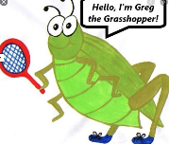
Lyng Primary School P.E Knowledge Organiser

Topic: Basketball | Year 5 | Autumn 2


Enquiry Questions
- What are the different ways of moving with the ball amongst your team?
- What is a double dribble? & What is travelling?
- What are the different types of passes?
- Where on the pitch can you get 3 points from scoring a basket?
- In a 2v1 situation against you, when is the best time to commit to the tackle?
- Can we transfer skills into a game situation?
Key words
Spelling | Definition
Possession | Having possession of the ball is when your team has control of the ball
3 pointer | Scoring from a certain area on a court worth 3 points.
Slam dunk | Slam dunk is a type of shot, where a player is air bound and makes the shot by slamming the ball through the hoop.
Free throw | Free throw is when a free shot is taken from a position on the court, the opposition are not allowed to prevent you from taking the shot.
Press | When the opposition have the ball and us as the defending team puts them under immediate pressure.
Chest pass | A type of pass made in basketball, pushing the ball from chest to chest.

“Don’t be afraid of failure. This is the way to succeed”
- Lebron James

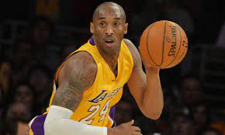

– Mav Levy
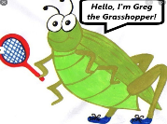
Lyng Primary School P.E Knowledge Organiser

Topic: Basketball | Year 5 | Autumn 2
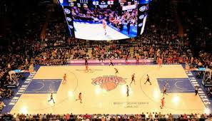
Learning Outcomes
- To practice change of direction when travelling at speed.
- To develop dribbling techniques.
- To improve different types of passes within basketball.
- To develop shooting with accuracy.
- To practice attacking and defending overloads i.e. 2v1 3v1 situations
- To put skills into game play.

